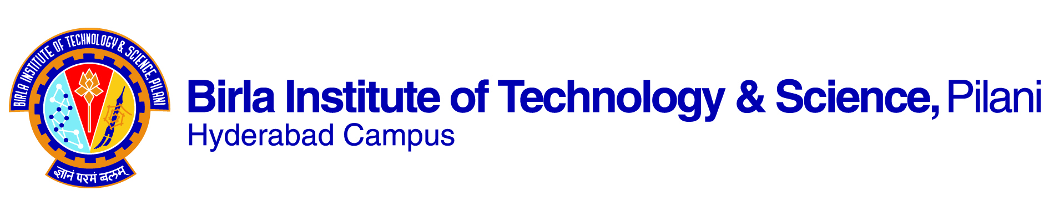

**SECOND SEMESTER 2022-2023**

**Course Handout Part II**

**Date: 16/01/2023**

In addition to part‑I (General Handout for all courses appended to the time table) this portion gives further specific details regarding the course.

Course No. : **CHEM F336**

Course Title : **Nanochemistry**

Instructor-in-charge : **Balaji Gopalan**

Instructor : -

***Course Description****:* Introduction, importance of nanoscience, chemistry behind nano; Instruments to be used for characterizing nanomaterials; Diversity in nanosystems: chemical aspects of metallic, semiconducting nanomaterials, nanocomposites, carbon nanotubes and fullerines, self-assembled monolayers, monolayer protected metal nanomaterials, core-shell nanomaterials; Applications of nano materials in nanobiology, nanosensors and nanomedicines, hands on experience in laboratory.

1. ***Scope & Objectives***: This is an elective course for chemistry discipline. Nanomaterials are ubiquitous in nature. Understanding the properties and its dependence on shape, size, and functional groups enables us to employ these nanomaterials for device applications. We will introduce the various nanosystems, study their properties and applications. Applications are limited in the fields of biology, sensors, medicine, and machines. The course also provides an opportunity to learn the synthetic techniques of nanomaterials, characterizations, familiar with various equipments etc.
2. ***Text Book*** : T . Pradeep, Nano: The Essentials, Understanding nanoscience and Nanotechnology, Tata McGraw-Hill Publishing Company Limited, New Delhi, 2007.
3. ***Reference Book***: 1) C. P. Poole Jr. and F. J. Owens, Introduction to Nanotechnology, Wiley Intescience 2003.

2) S. M. Lindsay, Introduction to Nanoscience, Oxford, 2010

3) G. Cao, Nanostructures and Nanomaterials, Imperial College press, 2004

4) Nanomaterials, B. Viswanathan Narosa Publishing House, New Delhi

1. **Course Plan**

|  |  |  |  |  |
| --- | --- | --- | --- | --- |
| Lect.  No. | Learning Objectives | Topics to be covered | Learning outcomes | Reference to Text book |
| 1 | Introduction | Nano the beginning, concept, importance | Origin of size effect, dimensionality surface to volume ratio | Class note |
| 2-5 | Instruments for the characterization of nanomaterials | Electron microscopes, Scanning probe microscope, X-ray diffractometer, XPS | Fundamental physical processes involved in characterization techniques | T1 2.1 – 2.6 |
| 6-10 | Metal nanoparticles: syntheses, characterization, properties, applications | Syntheses, properties of monolayer and polymer capped metal nanoparticles, Mie theory, controlling the size and composition of the metallic cores of nanoparticles, Sensoric and photoelectrochemical applications, catalysis, Anisotropic metal nanoparticle, Nanostructure: 2D array, 3D Superlattice | Concepts in synthesis, role of ligands, stabilization of colloids, optical properties of metals, self- assembly and structures | T1 8.1 – 8.6  T1 9.1 – 9.5 |
| 11-15 | Semiconducting nanoparticles: Syntheses, properties, characterization and applications | Quantum dots, Electronic structure, Semiconductor nanoparticle polymer composite, Optical properties | Defect chemistry, Excitons, concepts in synthesis, optical properties | T1 7.1 – 7.6 |
| 16-20 | Sell-assembled monolayers | Monolayers on gold, patterning monolayers, Langmuir Blodgett films, Applications of films in LED, Non-linear optical properties, Functionalization, superlattices | Preparation of monolayers, characterization techniques, properties | T1 5.1 – 5.7 |
| 21-23 | Carbon nanotubes | Syntheses, Structures, physical properties, Electronic properties, Mechanical Properties and applications | Graphite structure, Structure-property relationship, property characterization tools | T1 4.1 – 4.9 |
| 24-27 | Fullerenes | Syntheses and purification, Properties, Nanostructured fullerene films, Applications in electrocatalytic aspects and photoelectrical conversion of light energy, graphene | Structure-property relationship, property characterization tools (Raman spectroscopy) | T1 3.1 3.12 |
| 28-32 | Nanoparticles in catalysis | Introduction of nanoparticles in catalysis, Methods of preparation of supported metal nanoparticles, Applications of nanomaterials in various fields of catalysis | Mechanisms in catalysis, rate law, industrial important reactions | Class notes |
| 33-36 | Nanocomposite materials and Nanoshells | What are composite materials; Classification of nanocomposites: Nonpolymer based nanocomposites; Polymer based composites; | Microstructure-property relationship in materials | Class notes  T1 10.1 to 10.5 |
| 37-39 | Nanosensors | Based on optical properties, electrochemical sensors | Principle in sensor applications, lithography | T1 12.1 – 12.10 |
| 40-42 | Nanoparticles in Biological and biomimetic applications | Colloidal gold bioconjugates, Metal cluster conjugates, DNA and nanoparticles, DNA recognition, Biomimetic applications: Carbohydrate-protein and carbohydrate-carbohydrate interactions, Nanomaterials as delivery systems | Interface chemistry, basic aspects imaging and drug delivery science | T1 11.1 – 11.7  T1 13.1 – 13.7 |

***5. Evaluation Scheme****:*

|  |  |  |  |  |  |
| --- | --- | --- | --- | --- | --- |
| EC  No. | Evaluation  Component. | Duration  (min) | Weightage  (%) | Date, Time  & Venue. | Nature of Component. |
| 1 | Midsem | 90 | 25 | 18/03 9.30 - 11.00AM | Closed book |
| 2 | Lab component/assignments |  | 25 | Continuous | Open Book |
| 3 | Class tests/assignments |  | 15 |  | Surprise Closed book |
| 4 | Comprehensive  Examination | 180 | 35 | 19/05 FN | Closed book |

**6**. **Chamber Consultation Hours**: To be announced through a separate notice.

**7**. **Notices**: Notices concerning the course will be displayed in the **CMS**.

**8. Academic Honesty and Integrity Policy:** Academic honesty and integrity are to be maintained by all the students throughout the semester and no type of academic dishonesty is acceptable.

**9.** **Make-up-policy**: Make up would be considered only for very **genuine reasons** (***such as institute deputation outside for sports/cultural fest, hospitalization (with appropriate documentary proof), marriage ceremony of siblings (not cousins***)) and genuine grounds of sickness leading to hospitalization **(should be supported by medical documents**) etc.

Balaji Gopalan



Instructor-in-charge